[**Module 6**](https://eclass.srv.ualberta.ca/course/view.php?id=78354&section=8)

**Webpage Anatomy**

At the start of every UI or web design project, we want to design highly usable and self-evident applications, but we also want to devise innovative, compelling, and exciting interactions that make waves in the market. This week we will explore and understand the basic anatomy of a webpage and the four-step process to create good websites.

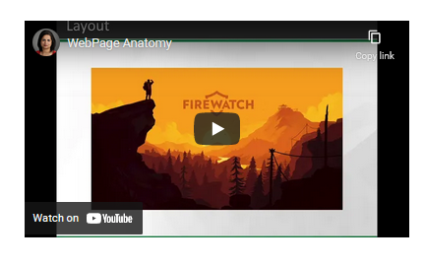

[**https://www.youtube.com/watch?v=2DlJitFav-Q**](https://www.youtube.com/watch?v=2DlJitFav-Q)

**Forms**

User Interface is important because it facilitates interactions between the user and your website or web application, and as it can turn potential visitors into buyers. A good User Interface design presents a seamless blend of visual design and interaction design; to create the seamless blend we need to design interactive and appealing UI elements. In the following video, I have shared some industry-set best practices to create one of the most important components of User Interface - Forms.

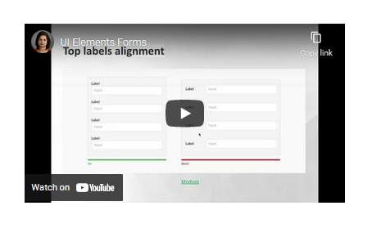

[**https://www.youtube.com/watch?v=pHsjqw2bEzw**](https://www.youtube.com/watch?v=pHsjqw2bEzw)